**4. User Interface Issues:**

Our project is about Kurbani cow provider service. This is web base website

which is user friendly. When user will search our site like to write KurbaniCowPro-

vider.com by any search engine then they will see our home page like this:

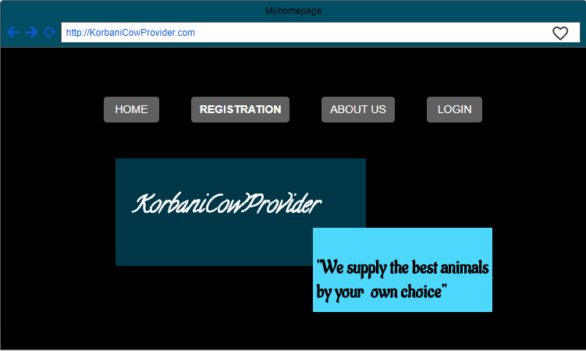

Then when they click log in button then user will see log in page which is need for

different type of user like:

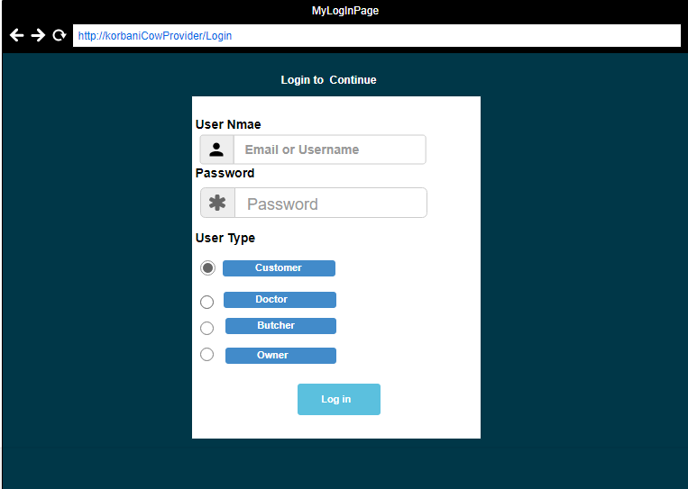

then user can log in as a customer or doctor or so on. When user logged in as a customer thencustomersee customerpage like this:

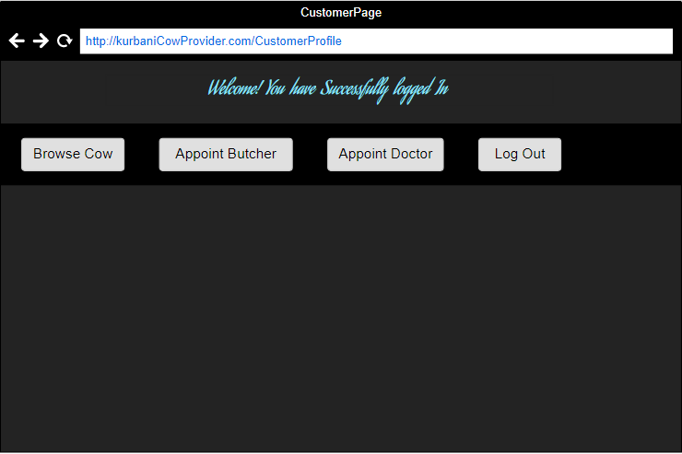

customer can add their cow information what type of animal they want, this page

like this:

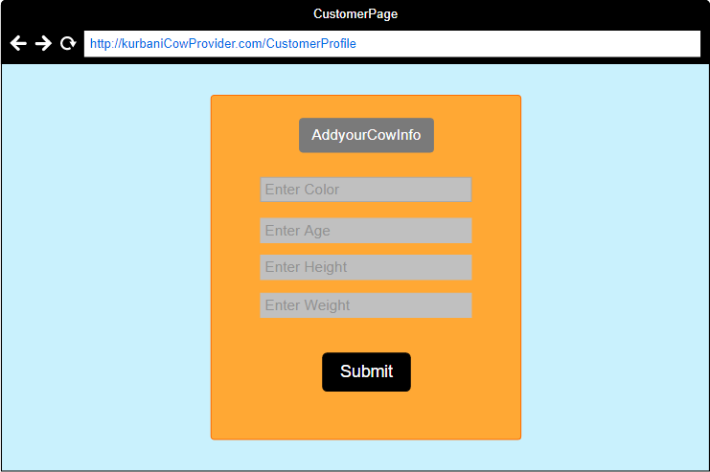

when user click Registration button then user will see registration or sign up page which is need for different type of user like:

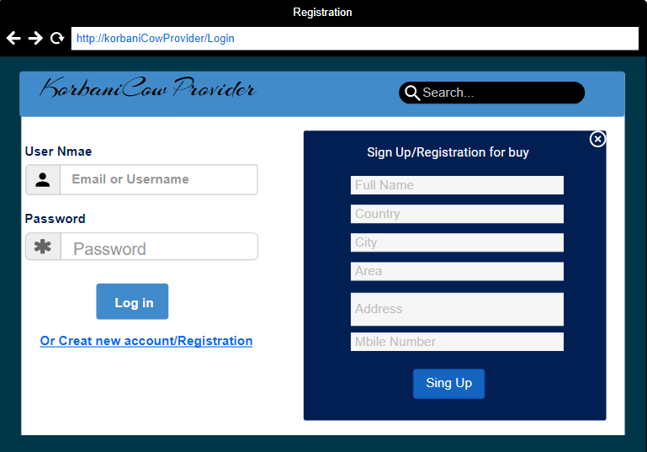

then user can also log in as a Doctor. When user logged in as a customer thencustomerwillsee doctorpage like this:

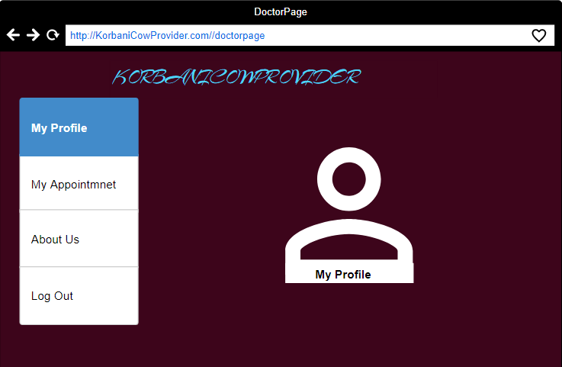

User can also log in as a Butcher. When user logged in as a Butcher thencustomerwillsee butcherpage like this:

